Vacation Bible School ~~~ 2019
Teen Volunteer Application
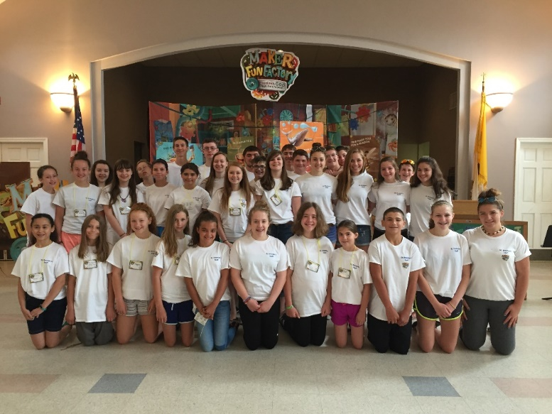
Interested in volunteering as a team leader for Vacation Bible School?

You must be at least 12 years of age by September 1st, and entering Grade 7 or older.
If you are interested, please fill out the volunteer form on the reverse side of this application and return it to Mrs. Griffin in the Parish Office:
Mrs. Gladys Griffin, St. Brendan Parish Office, 384 Hartford Ave., Bellingham, MA 02019-1217

Questions? Feel free to call or email the Parish Office:
508-966-9802 or gladys.saintbrendan@verizon.net

2019 - VACATION BIBLE SCHOOL VOLUNTEER APPLICATION

(1) Name: _________________________________________________ email: __________________________________________

Age (a/o 8/31/2019)_________ Grade entering 9/2018: __________ parent’s email: ______________________________________

(2) Name: _________________________________________________ email: __________________________________________

Age (a/o 8/31/2019)_________ Grade entering 9/2018: __________ parent’s email: ______________________________________

(3) Name: _________________________________________________ email: __________________________________________

Age (a/o 8/31/2019)_________ Grade entering 9/2018: __________ parent’s email: ______________________________________

Address: ___________________________________________________________________________________________________
Street Town Zip

Parent’s phone: ______________________________________________________________________________________________
home cells

Your cell phone: _____________________________________________________________________________________________

July 8 - 12

8:30 A.M. to 12:15 P.M.

Areas where we need help before VBS: decorations, posters, banners, and set-up.
Areas where we need help during VBS: music, Imagination Station, Bible Discovery, Game Makers, Snack factory, group leaders, preschool child care, Kid Vid Cinema and breakdown at the end.

We can’t make any promises as to where you will be placed, however, if you have a preference or a special idea, you may note it here: _______________________________________________________________________________________________________

_______________________________________________________T-shirt size: _______________________________________

The help of young people in the past has been invaluable. If you are interested in applying and are accepted into the program, this would be considered service work. The sessions would run from 8:30 A.M. until 12:15 P.M. daily. We do ask, if it is at all possible, that you commit to all five days.

Due to the nature of our work, if accepted into the program, you would be required to attend an instructional meeting sometime before the start of VBS. You will receive notification of meeting times.

THANK YOU FOR YOUR WILLINGNESS TO HELP! Please return this to Mrs. Griffin in the Parish Office A.S.A.P.

St. Brendan Parish Office, 384 Hartford Ave., Bellingham, MA 02019

PLEASE RETURN FORM BY FRIDAY, MAY 24, 2019

